الاسم:عمر محمد محمود حسنين (2)
Chapter 9
Choices:
1) Which Python library is commonly used to send HTTP requests to fetch web pages (b)
2) Which library is used to parse HTML and extract data from it (c)
3) What is the HTTP status code for a successful request (c)
4) Which BeautifulSoup method is used to find all occurrences of a specific tag (b)
5) How do you access the value of an attribute (like href) in a BeautifulSoup tag object (d)
True or false:
1) The requests library executes JavaScript code on a webpage (false)
2) BeautifulSoup is used to send HTTP requests to servers (false)
3) find_all() method returns a single tag object (false)
4) Web scraping is allowed on all websites without any restrictions (false)
5. You can search for tags using CSS classes in BeautifulSoup (true)
Short answers:
- What is the difference between find() and find_all() methods?
Answer: • find(): Returns the first matching tag found (single object).
• find_all(): Returns a list of all matching tags found in the document.
- Explain the role of the requests library in web scraping.
Answer: It allows Python to send HTTP requests (like GET) to a specific URL and retrieve the webpage's content (HTML code) so we can analyze it.
- What is the purpose of checking status_code after a request?
Answer: To ensure the request was successful. A code of 200 means success, while 404 means "Not Found" and 403 means "Forbidden".
- Why is it important to inspect the HTML structure (Inspect Element) before scraping?
Answer: To identify the specific tags IDs, and Classes that contain the data we want to extract.
Problems:

Problem 1: 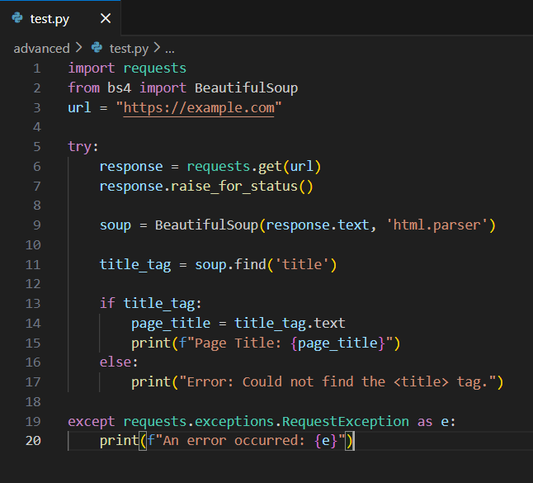
Problem 2 : 